#
# 20190417
# Sometime it’s happen to forget to push all changed on nag-tst files into the git.
# After that not consistent configuration cannot be pulled from git on nag-prod. The configuration wouldn’t be worked if it pulled from git to nag-tst with force.
# Auto checks send follow notifications about not working on nag-prod nagios configuration.
#
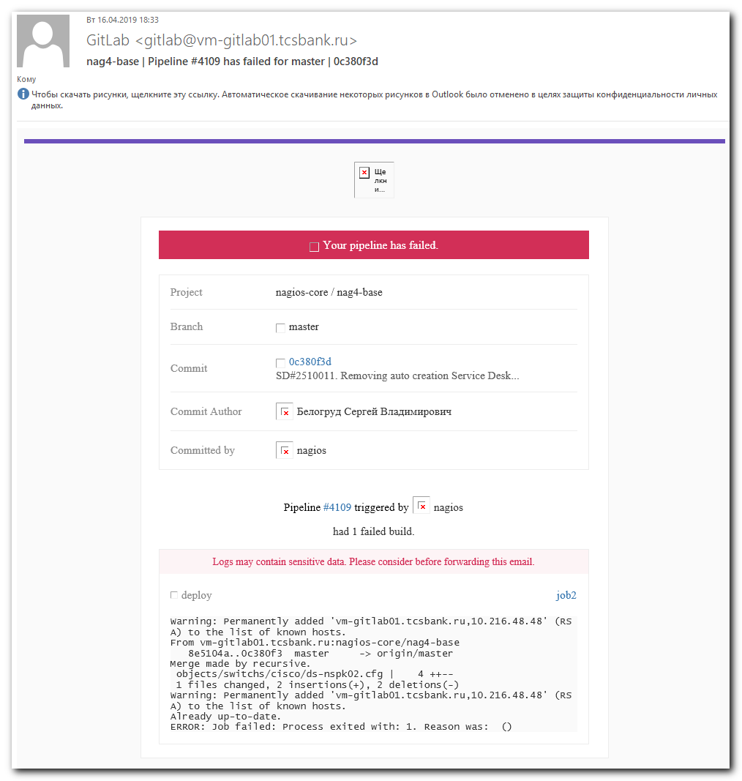

#
# To find source of problems, it’s need to run follow command on nag-prod.
#
[root@vm-vol-nag4-prod objects]# nagtst

Nagios Core 4.3.4
Copyright (c) 2009-present Nagios Core Development Team and Community Contributors
Copyright (c) 1999-2009 Ethan Galstad
Last Modified: 2017-08-24
License: GPL

Website: https://www.nagios.org
Reading configuration data...
Read main config file okay...
WARNING: The retry_check_interval attribute is deprecated and will be removed in future versions. Please use retry_interval instead.
WARNING: The retry_check_interval attribute is deprecated and will be removed in future versions. Please use retry_interval instead.
WARNING: The retry_check_interval attribute is deprecated and will be removed in future versions. Please use retry_interval instead.
WARNING: The retry_check_interval attribute is deprecated and will be removed in future versions. Please use retry_interval instead.
WARNING: The retry_check_interval attribute is deprecated and will be removed in future versions. Please use retry_interval instead.
Error: Contactgroup 'windows-admins-wo-sd' is not defined anywhere
Error: Could not add contactgroup 'windows-admins-wo-sd' to host (config file '/usr/local/nagios/etc/objects/servers/vmware/ds-pr-mma01p.cfg', starting on line 1)
Error processing object config files!

***> One or more problems was encountered while processing the config files...

Check your configuration file(s) to ensure that they contain valid
directives and data definitions. If you are upgrading from a previous
version of Nagios, you should be aware that some variables/definitions
may have been removed or modified in this version. Make sure to read
the HTML documentation regarding the config files, as well as the
'Whats New' section to find out what has changed.

[root@vm-vol-nag4-prod objects]# /usr/local/nagios/libexec/opt/scripts/git_puller.sh
Warning: Permanently added 'vm-gitlab01.tcsbank.ru,10.216.48.48' (RSA) to the list of known hosts.
Already up-to-date.
Warning: Permanently added 'vm-gitlab01.tcsbank.ru,10.216.48.48' (RSA) to the list of known hosts.
Already up-to-date.
Running configuration check...
Reloading nagios configuration...
done
[root@vm-vol-nag4-prod objects]#

#
# After problem was resolved and appropriate files were commetted into

[root@vm-vol-nag4-prod objects]# /usr/local/nagios/libexec/opt/scripts/git_puller.sh
Warning: Permanently added 'vm-gitlab01.tcsbank.ru,10.216.48.48' (RSA) to the list of known hosts.
Already up-to-date.
Warning: Permanently added 'vm-gitlab01.tcsbank.ru,10.216.48.48' (RSA) to the list of known hosts.
Already up-to-date.
Running configuration check...
Reloading nagios configuration...
done
[root@vm-vol-nag4-prod objects]# nagtst

Nagios Core 4.3.4
Copyright (c) 2009-present Nagios Core Development Team and Community Contributors
Copyright (c) 1999-2009 Ethan Galstad
Last Modified: 2017-08-24
License: GPL

Website: https://www.nagios.org
Reading configuration data...
Read main config file okay...
WARNING: The retry_check_interval attribute is deprecated and will be removed in future versions. Please use retry_interval instead.
WARNING: The retry_check_interval attribute is deprecated and will be removed in future versions. Please use retry_interval instead.
WARNING: The retry_check_interval attribute is deprecated and will be removed in future versions. Please use retry_interval instead.
WARNING: The retry_check_interval attribute is deprecated and will be removed in future versions. Please use retry_interval instead.
WARNING: The retry_check_interval attribute is deprecated and will be removed in future versions. Please use retry_interval instead.
Read object config files okay...

Running pre-flight check on configuration data...

Checking objects...
Checked 29718 services.
Checked 4095 hosts.
Checked 130 host groups.
Checked 38 service groups.
Checked 1365 contacts.
Checked 143 contact groups.
Checked 211 commands.
Checked 58 time periods.
Checked 0 host escalations.
Checked 79 service escalations.
Checking for circular paths...
Checked 4095 hosts
Checked 0 service dependencies
Checked 0 host dependencies
Checked 58 timeperiods
Checking global event handlers...
Checking obsessive compulsive processor commands...
Checking misc settings...

Total Warnings: 119
Total Errors: 0

Things look okay - No serious problems were detected during the pre-flight check
[root@vm-vol-nag4-prod objects]#

